Ode to the Midlands
Call for Artists
Open to Global Majority, Disabled, Deaf, and/or Neurodivergent mid-career visual artists living or professionally-based in the East Midlands & West Midlands
Applicant Q&A: Wednesday 18 February, 2pm (online, via Zoom)
Contact Colette Griffin at colette@cvaneastmidlands.co.uk to book onto the open OttM information session, or to request an online 1-2-1 conversation. This is an opportunity to discuss queries relating to the project or application process. 1-2-1 meetings will last for 15 minutes.

Deadline: Wednesday 25 March 2026, 10am
Responses: Friday 24 April 2026, 5pm
Contents
Page 1: Project Overview
Page 2: Who are CVAN EM & CVAN WM?
Page 3: Key Term Glossary
Page 3: Commission Opportunity
Page 4: Overview of Support
Page 4: Who can apply?
Page 6: Eligibility map
Page 7: Selection Process
Page 7: Commissioning Organisations & Pairing
Page 8: How to apply
Page 9: Application Form
Project Overview
Ode to the Midlands (OttM) is an ambitious, cross-regional programme delivered over 18 months by Contemporary Visual Arts Network East Midlands (CVAN EM) and Contemporary Visual Arts Network West Midlands (CVAN WM) to enrich cultural life in the Midlands by investing in local talent and publics.
Rooted in equity, collaboration, and digital innovation, OttM builds cross-regional connectivity by fostering relationships between artists, organisations, and audiences across the East and West Midlands. OttM is working with 6 partner organisations, split across both regions to commission 6 Global Majority, Disabled, Deaf, and/or Neurodivergent mid-career artists to produce digital works that explore, celebrate, and reflect the Midlands’ rich cultural and geographical identity.
Central to the programme is a unique pairing process that will see visual arts organisations (large or small) work with artists from their neighbouring region to strengthen collaboration and exchange.
OttM champions sustainable artist development through commissions, mentoring, peer learning, and professional support, while also investing in organisational development, helping partners build the confidence, skills, and frameworks needed for inclusive digital commissioning.
With the East and West Midlands historically underrepresented in the national visual arts narrative, low in creative employment, and among the least funded regions in the UK, OttM responds to sector needs by supporting artists to create and present new digital artworks. Presenting artworks online, in galleries, and in public spaces, it expands access for rural, Disabled, and time-poor audiences, creating lasting connectivity and a legacy of inclusive digital arts across the region.
Grounded in the core work of our Network hosts, New Art Exchange and DASH, OttM ensures creatives from marginalised backgrounds and historically excluded from immersive and digital practice gain visibility, resources, and networks. An Advisory Group of Midlands-based audiences, artists and arts workers will help guide the programme and selection process, embedding inclusive practice and shared decision-making.
Through collaborations with regional universities, OttM will deliver a free public workshop series designed to share digital skills, foster experimentation, and build sector confidence. These workshops, led by locally based artists and technicians, will support both artists and wider publics to engage meaningfully with new technologies and inclusive creative practice.
In partnership with Corridor8, OttM will also platform critical and creative writing from Midlands-based arts writers, offering reflective responses to the commissioned works and further amplifying regional voices.
Ode to the Midlands is supported using public funding by the National Lottery through Arts Council England.
Who are CVAN EM & CVAN WM?
CVAN EM & CVAN WM are the free-to-access Contemporary Visual Arts Networks for the East and West Midlands, working as part of the national CVAN network. We advocate for contemporary visual arts in the regions by supporting artists, arts workers, and organisations through paid opportunities, critical programming, and partnership working, while driving policy change to ensure a sustainable and vibrant sector. Both networks are guided by diverse Steering Groups of arts professionals including artists, technicians, writers, curators, producers, academics and access support workers.
Since 2023, CVAN EM has been hosted by New Art Exchange (NAE). NAE is a ground-breaking creative space in the heart of Hyson Green, Nottingham and the UK’s largest gallery dedicated to contemporary visual arts from the Global Majority. NAE is dedicated to promoting excellence in culturally diverse contemporary arts through exhibitions, events and engagement initiatives. The organisation champions a citizen-led model to programming, commissioning and decision making.

Since 2023, CVAN WM has been hosted by DASH. DASH is a Disabled-led, visual arts charity with a vision for a world where Disability Art is equally valued. The organisation’s mission is to affect sector change, to remove barriers to access, establishing Disability Arts practice as part of the mainstream.
Across core activities, DASH tackles systemic inequalities to create space for extraordinary artists to make work and be heard. Talent development is at the core of what DASH does, supporting Disabled, Deaf and Neurodivergent creatives.
Key Term Glossary
Global Majority: NAE and CVAN EM define “Global Majority” as a collective term that refers to people who are Black, Asian, Brown, dual heritage, Indigenous to the global South, and/or people who have been racialised as ethnic minorities.
Disabled: DASH and CVAN WM use an expansive definition of “disabled” including Disabled, Deaf, chronically ill, neurodivergent, Crip, Mad, sick and Spoonie.
Visual Arts: CVAN EM & CVAN WM considers the visual arts to focus on contemporary artistic practice and include fine arts, crafts, photography, moving image, live art and performance, socially engaged art, new media and digital art, and any crossover with design, architecture or other creative disciplines.
Commission Opportunity
This is an opportunity to apply to be an OttM Commissioned Artist, joining a network of 6 artists who will develop and deliver ambitious digital artworks across this cross-regional programme.
As an OttM Commissioned Artist, you will develop and present a new digital artwork that explores, celebrates, and reflects the Midlands’ rich cultural and geographical identity, supported by mentorship, peer exchange, access funding, editorial writing, and promotional support.
Commissions may be presented online, in galleries, or in public spaces, and can take many forms, including exhibition, event, performance, intervention, hybrid installation, web-based work, or activity-based projects. Commissions will be reflective of the parameters of the modest budget available and and the commissioning organisation’s programme, resources and capacity.
For OttM, digital artwork refers to creative work that uses digital technology as an essential element of its concept, production, or presentation. This may include, but is not limited to:
- moving image and video
- digital image-making or illustration
- sound, music, or sonic environments
- web-based or browser-based work
- creative coding, and generative processes
- artificial intelligence and machine-learning–based practices
- AR, VR, or mixed-reality
- projections and spatial media
- interactive or participatory digital experiences
- hybrid installations combining physical and digital elements.
We welcome applications from artists with established digital practices, as well as from those who are new to digital practice and wish to use this opportunity to develop creatively and professionally in this area.
If you would like to discuss or get further clarification regarding the definitions provided above relating to eligible practice, please contact Colette Griffin at colette@cvaneastmidlands.co.uk.
Overview of Support
Each commissioned artist, working in partnership with a commissioning organisation in the neighbouring region, will receive the following support through OttM:
- Artist & Production/Installation Fee: A fee of £10,000 (inclusive of VAT) to cover your artist fee, production costs, and presentation costs for the new digital work.
- Access Support: Access funds drawn from a £10,000 total access budget across the OttM programme. This may include access support for research, production or presentation.
- Travel and Collaboration: Access to a shared total travel and accommodation budget of £5,500, to support cross-regional collaboration between you and your commissioning organisation.
- Professional Development: Bespoke mentoring, consultation, and skills development, offered through a combination of group sessions and 1–2–1 support with freelance arts professionals including artists, curators, and specialist technicians.
- Peer Exchange: Connecting you with the other commissioned artist for shared learning and support.
- Editorial & Critical Writing: A written review, article, or feature on your commissioned artwork by a Midlands-based arts writer, commissioned and published by Corridor8, providing public visibility and critical context for your work.
- Documentation: Photographic documentation of your commissioned artwork (where relevant to outcome format), ensuring a lasting record and contributing to your portfolio and future opportunities.
- Technical Support: 2.5 technician days (at £180 per day) to support the development and/or delivery of the commissioned work.
- Visibility & Promotion: Visibility and promotion through OttM’s communications.
In return, artists are expected to:
- Develop and deliver a new digital artwork (April 2026 – March 2027)
- Collaborate with a commissioning organisation in the neighbouring region
- Express the cultural and geographical identity of the Midlands
- Take part in mentoring and peer sessions
- Engage with audiences and communities
- Contribute to shared learning, evaluation and legacy
Who Can Apply
To apply for this OttM open call for visual artists, you must be:
- Living or professionally-based in the East or West Midlands as defined by CVAN EM & CVAN WM geography. A visual map is provided below to support applicants in identifying regional eligibility. The regions encompass the counties of:
  - East Midlands: Derbyshire, Leicestershire, Lincolnshire (not NE), Northamptonshire, Nottinghamshire & Rutland.
  - West Midlands: Herefordshire, Shropshire, Staffordshire, Warwickshire, West Midlands & Worcestershire.
- Identify as Global Majority, Disabled, Deaf, and/or Neurodivergent. See the glossary on page 3 for more information on how CVAN EM & CVAN WM define these terms.
- Mid-career/an established practitioner looking to expand. You should consider yourself to be at a mid-career stage in your artistic practice. We welcome a broad definition of mid-career and do not require a particular education route or length of practice. You are invited to tell us what mid-career means in relation to your journey.
- Over 18. You must be aged 18 or over at the time of applying.
- Not studying at BA/MA level. Applicants must not be enrolled on a BA or MA at the time of applying. PhD candidates are welcome to apply.
Collectives: Artist collectives, duos and collaborative practices are welcome to apply. However, please note that the artist fee is fixed and will not be increased if awarded to a collective, duo, or group. It is the responsibility of the collective to determine how the labour and fee is shared within the group.
Digital Practice: Applicants are not required to currently have a digital practice, and may use this opportunity to experiment, learn and develop creatively and professionally in this area, diversifying their practice.
In this case, you must demonstrate in your application A clear interest in digital practice, and the capacity and commitment to develop skills during the commission.
We equally absolutely welcome applications from artists with established digital practices.
Applicants should be able to demonstrate:
- The experience required to work collaboratively with a commissioning organisation
- A clear commitment to inclusive and accessible practice
- The capacity to develop and deliver a digital commission between April 2026 – March 2027.

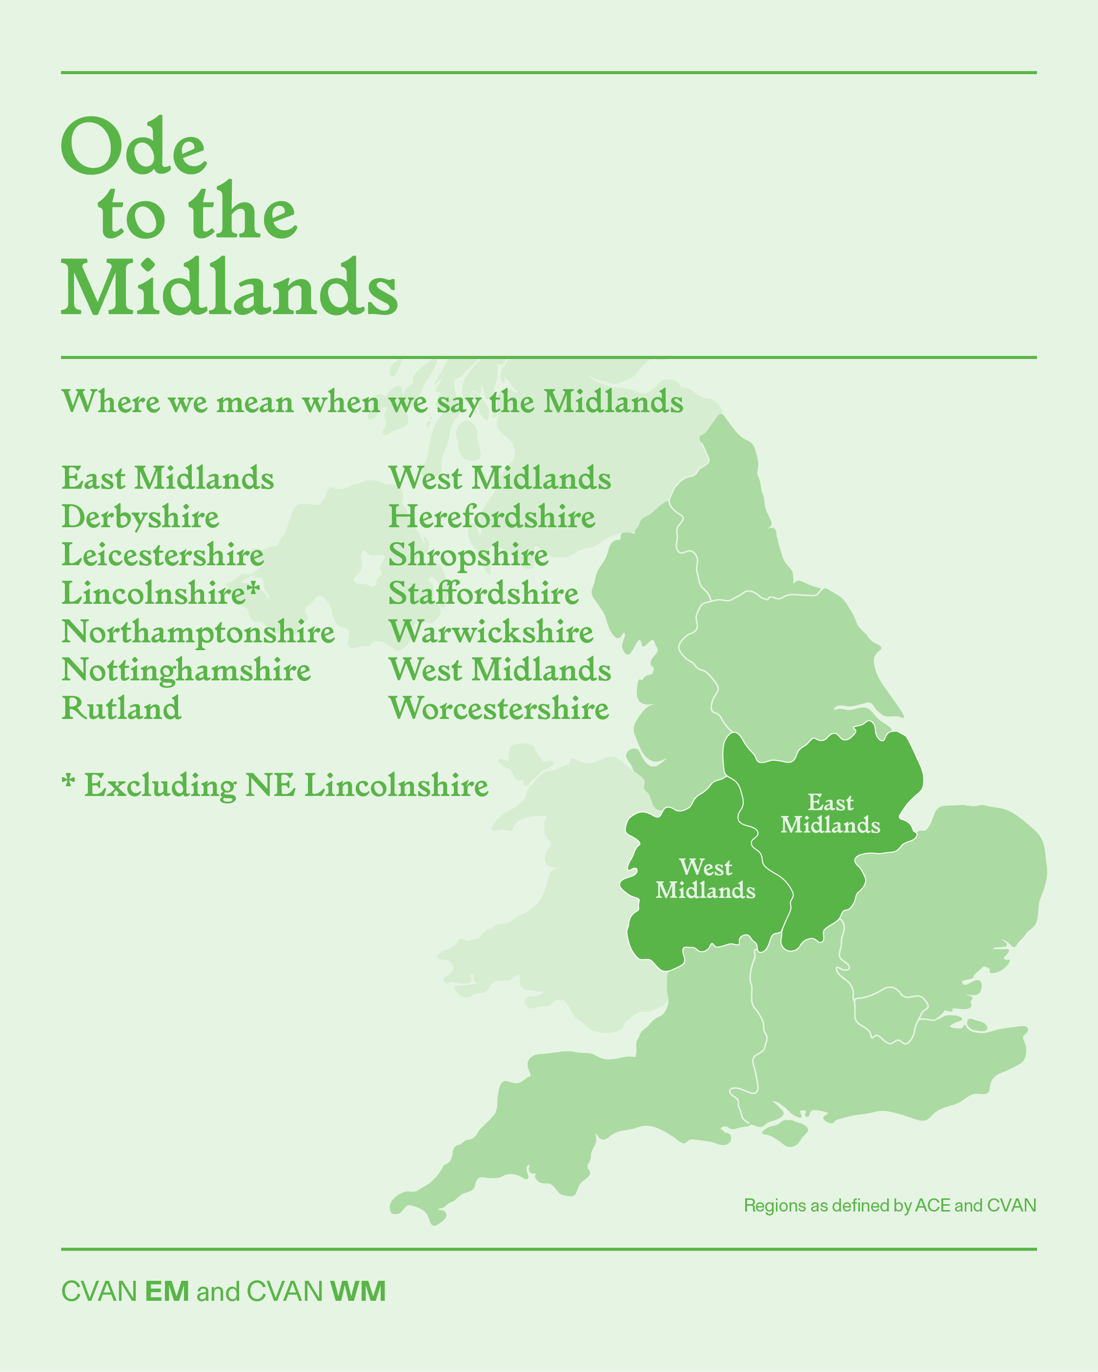

Selection Process
Applications will be reviewed and selected by OttM Commissioning Organisations from your neighbouring region and the OttM Advisory Group, a group of Midlands-based artists, arts workers, and audience representatives with diverse expertise and lived experience.
The Advisory Group will assess applications against the following criteria:
- Artistic quality and clarity of practice, including the strength of visual/portfolio materials and the applicant’s ability to articulate their ideas, interests, working methods, and context.
- Clear expression of interest in producing a new digital work that explores, celebrates, and reflects the Midlands’ rich cultural and geographical identity.
- Fit with project aims, demonstrating how the applicant’s practice and/or their desire to develop new digital skills aligns with the objectives of OttM and its focus on regional identity.
- Potential for public engagement and legacy, including how the artist’s proposed direction of work may connect with communities, audiences, and place-based narratives across the Midlands.
- Readiness and capacity to develop and deliver a digital commission between April 2026 – March 2027, including openness to collaboration with a commissioning partner in the neighbouring region.
In addition to the criteria above, the process will also seek to ensure:
- a spread of artists across the wider Midlands geography
- and a diversity of artistic approaches, disciplines, and digital practices.
All decisions will be made collectively by the OttM Commissioning Organisations & the OttM Advisory Group, ensuring a fair, transparent, and regionally representative selection process.

Commissioning Organisations & Pairing
OttM brings together a network of commissioning organisations across the East and West Midlands, representing a broad range of scales, remits, and approaches within the visual arts.
OttM Commissioning Organisations are:
- Film and Video Umbrella (East Midlands)
- NN Contemporary Art (East Midlands)
- The Hub (East Midlands)
- British Ceramics Biennial (West Midlands)
- Hereford Museum & Art Gallery (West Midlands)
- Meadow Arts (West Midlands)
Each commissioned artist will be paired with one commissioning organisation in the neighbouring region. East Midlands artists will be paired with West Midlands organisations and vice versa. This pairing supports cross-regional exchange, opens new contexts for your work, and builds long-term regional connections.
Artists do not select or contact an organisation as part of this application. Pairings will be made during the selection process, led by the OttM Advisory Group in collaboration with the commissioning organisations. This helps ensure an equitable and transparent process, rather than an application driven by existing networks or institutional access.
Pairing decisions will consider:
- Opportunities for relationship-building and future collaboration
- Alignment between the artist’s practice and the organisation’s context
- Access to relevant resources, facilities, or local networks
- The organisation’s experience and capacity to support the proposed approach.
This means you should not write your application with a specific organisation in mind. Instead, focus on your practice, interests, and ideas relating to OttM and what you want to explore, celebrate, or reflect about the Midlands’ cultural and geographical identity.
Once pairings are confirmed, OttM will support the organisation and artist to create a way of working together that centres care, access, equity, and shared learning. The partnership will include the development and presentation of your new digital artwork, alongside mentoring, peer exchange, and opportunities to build new relationships across the region.

How to Apply
Artists interested in being commissioned for OttM are invited to submit an application outlining their practice, motivation, and interest in producing a new digital work that explores, celebrates, and reflects the Midlands’ rich cultural and geographical identity.
Your application should include:

About your practice: A short overview of your artistic practice.

Your interest in the opportunity: Why you want to participate in OttM and how your practice and/or your desire to develop new digital skills aligns with the aims of the commission and its focus on regional identity.

Why are you interested in producing a new digital work that explores, celebrates, and reflects the Midlands’ cultural and geographical identity.
  - Ideas should not be fully formed; there needs to be scope for development throughout the project, a dialogue between commissioning organisation and artist, considering how the work fits within the organisation’s programme, resources and capacities.

- Impact on practice: How you hope this opportunity will support your creative and professional development.

Collaboration, inclusion, and access: How do you embed equity and accessibility in your practice and/or are interested in developing this strand through an OttM commission.

Visual/portfolio materials. Examples of your work. This can include up to:

10 images, and/or

5 links to video, website, social media or documentation, and/or

a short portfolio PDF (max 5 pages), with captions.
- Applicants should all submit an equal opportunities monitoring form here.
Applications can be submitted in written (up to 800 words total), audio (up to 6 minutes total), or video (up to 6 minutes total) format. The total word count/duration can be divided between the four sections in any way you choose.
Work can be from any stage of your practice, but we are most interested in seeing more recent examples. Artists who are new to digital practice are encouraged to include work that shows their approach, thinking, or adjacent skills.
We accept applications submitted as attachments, in the body of an email or via Google Drive. All applications must still respond to the criteria above and address all sections of the application form in their responses.
Access & Equal Opportunities:

You may outline any access requirements or support needs for the commission period. If submitted access requirements/access riders will not be shared with the selection panel but will be kept on record for use if you application is progressed.
If you require this information in an alternative format or would like to discuss general queries or access requirements in advance of applying, please contact Colette Griffin on colette@cvaneastmidlands.co.uk.
Important Dates:
Please send your application to Colette Griffin at colette@cvaneastmidlands.co.uk by Wednesday 25 March 2026, 10am.
All applicants will receive an acknowledgment of submission. Outcomes will be shared by Friday 24 April 2026, 5pm.
Application Form

Artist Details
Artist Name: | Artist Address:
Artist Email: | Artist Address:

Application

1. About your practice: A short overview of your artistic practice.
- We want to know what ideas and interests underpin the work you make.
- Any achievements, projects, or commissions you would like to share.
2. Your interest in the opportunity: Why you want to participate in OttM and how your practice and/or your desire to develop new digital skills aligns with the aims of the commission and its focus on regional identity.
- Why are you interested in producing a new digital work that explores, celebrates, and reflects the Midlands’ cultural and geographical identity.
- Ideas should not be fully formed; there needs to be scope for development throughout the project, a dialogue between commissioning organisation and artist, considering how the work fits within the organisation’s programme, resources and capacities.

3. Impact on practice: How you hope this opportunity will support your creative and professional development.
4. Collaboration, inclusion, and access: How do you embed equity and accessibility in your practice and/or are interested in developing this strand through an OttM commission.

